Michael Derby -
Partnership Announcement

Kirk Polson, Derek Polson and Paul Bourbonniere are delighted to announce the partnership of Michael Derby in the newly branded Polson Bourbonniere Derby Wealth Management. The addition of Michael to the leadership of the firm is a statement of our commitment to the continuity and growth of our business, while our new name reflects our broad and diverse offering of financial services and products. As we celebrate our 20th anniversary this year, the addition of Michael as a new partner is but one step taken to ensure that our business continues to thrive through the next 20 years and beyond.

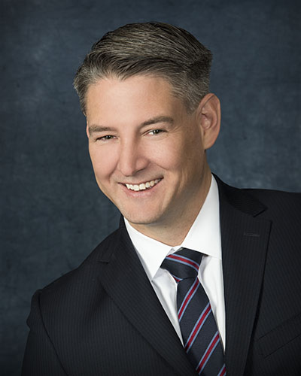
Michael joined the team in 2011, with an undergraduate degree from Texas Tech and experience as a financial advisor in the US offices of American Express. After completing his studies to obtain his registration as an Investment Advisor with the Investment Industry Regulators of Canada (IIROC), and his life insurance agent licensing with the Financial Services Commission of Ontario (FSCO), Michael also went on to earn his CIM (Chartered Investment Manager) and Certified Executor Advisor (CEA) designations.

In 2014, as part of his retirement preparation, Allan Kalin - a long-time associate within the firm - began the process of transitioning the care of his clients to Michael which has proven to be a tremendous success. Since 2014, Michael has seen growth of 150% in his Assets Under Management and has enjoyed a steady stream of referrals from satisfied clients.

Please join us in congratulating Michael on this achievement!
Michael Derby, CIM®, CEA

